**Format for uploading details in Github and Slack in word file format**

**(Fill this format(docx) daily and upload it in both Github and Slack)**

**Student Name : SURYA PRAKASH S**

**Class and Sec : VI B**

**USN : 4AL17CS101**

|  |  |  |  |  |
| --- | --- | --- | --- | --- |
| **Online Test Details** | | | | |
| **Subject** | **-** | | | |
| **Semester** | **VI -B** | | **Duration** | **-** |
| **% of marks** | | **-** | | |

**Encl : snapshot of the test result**

|  |  |  |  |
| --- | --- | --- | --- |
| **Certification Course Details** | | | |
| **Course** | **Programming in Java**  **Data Structures** | | |
| **Certificate Provider** | **-** | **Duration** | **04 hours** |

**Encl : snapshots of the daily class acitivities (atleast two snap shots)**

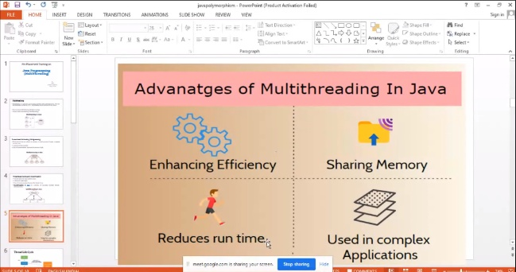

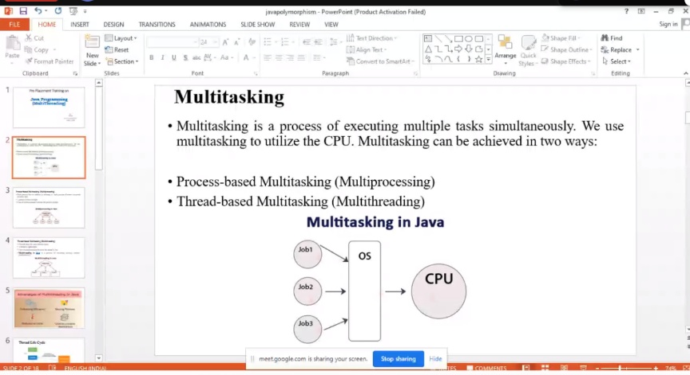

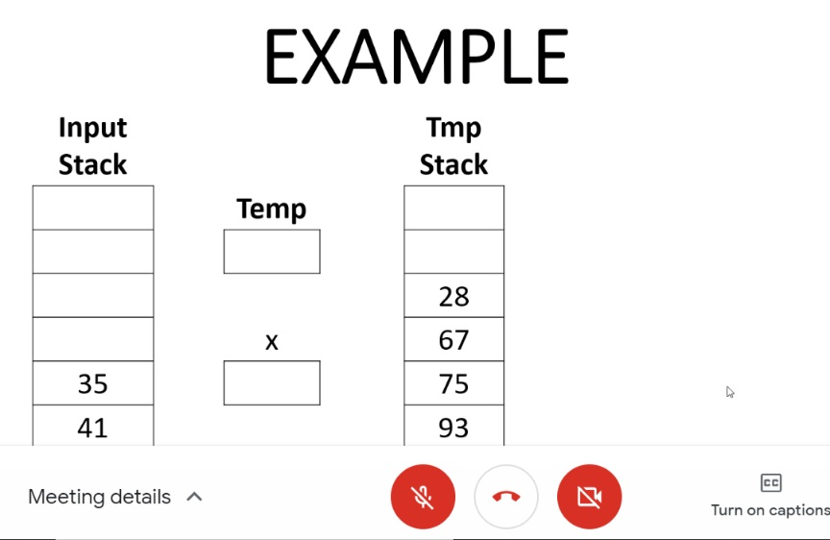

|  |  |
| --- | --- |
| **Coding Challenges** | |
| | **Problem Statement: 1. Python Program to Create a Class and Compute the Area and the Perimeter of the Circle 2. Create a class named 'Shape' with a method to print "This is This is shape". Then create two other classes named 'Rectangle', 'Circle' inheriting the Shape class, both having a method to print "This is rectangular shape" and "This is circular shape" respectively. Create a subclass 'Square' of 'Rectangle' having a method to print "Square is a rectangle". Now call the method of 'Shape' and 'Rectangle' class by the object of 'Square' class** | | --- | | |
| **Status: Completed** | |
| **Uploaded the report both in Github & Slack** | **Yes** |

**Encl : snapshots of your response to challenge.**

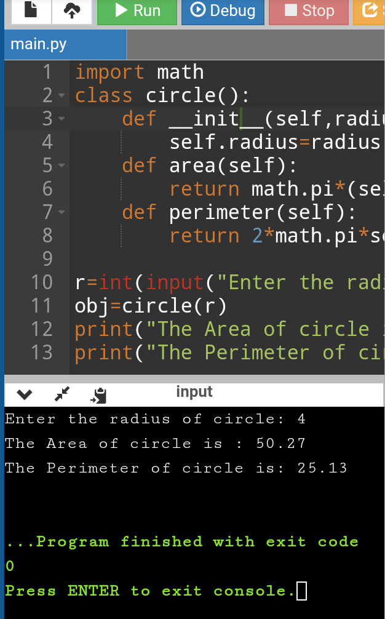

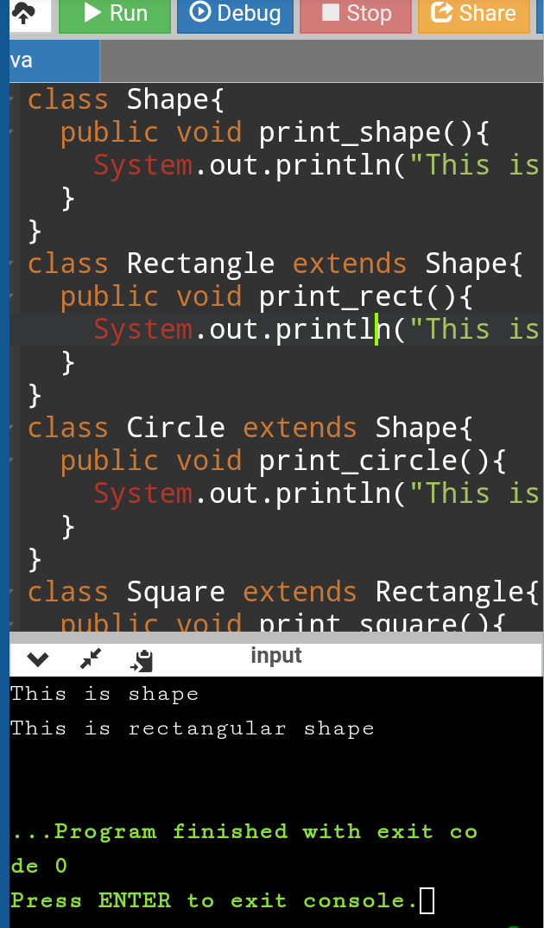

https://github.com/SPSSURYA/Online-Coding-And-Certification-Course